**Asia-China-Coin-Wang Mang-Key**

**Yi Dao Ping Wu Qian** (Chinese: 一刀平五千; pinyin: yīdāo píng wǔqiān; literally "One Knife Worth Five Thousand") on which the Yi Dao characters are inlaid in gold.一刀平五千

Listed below on left is British Museum example, followed by authentic examples and then forgeries below.

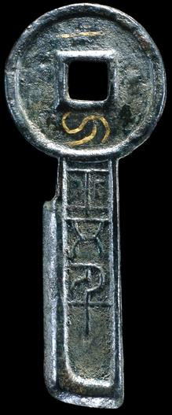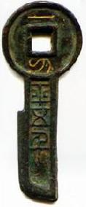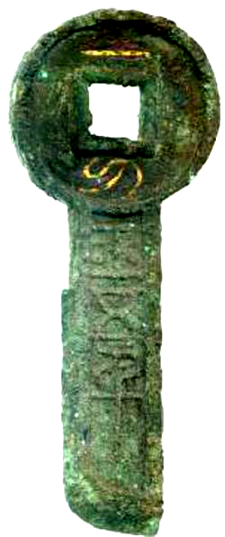 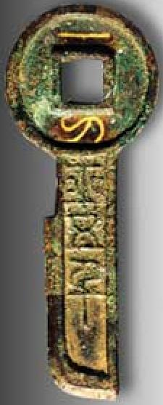

1. BM 2. 3. 4. Shanghai Bank Museum

